MISSION
To provide a respite weekend in the Colorado Rockies for married couples that have experienced the death of a child.  VISION  “Praise be to the God and Father of our Lord Jesus Christ, the Father of compassion and the God of all comfort, who comforts us in all our troubles, so that we can comfort those in any trouble with the comfort we ourselves receive from God.”  2 Corinthians 1:3-4  contact information  Kelly Packard  Executive Director  PHONE: 765-717-3892  WEBSITE:  www.livinghopemountainrespite.com  EMAIL:  info@livinghopemountainrespite.com  FACEBOOK:  @livinghopemountainrespite  ADDRESS:  471 Ute Peak Drive  Livermore, Colorado 80536  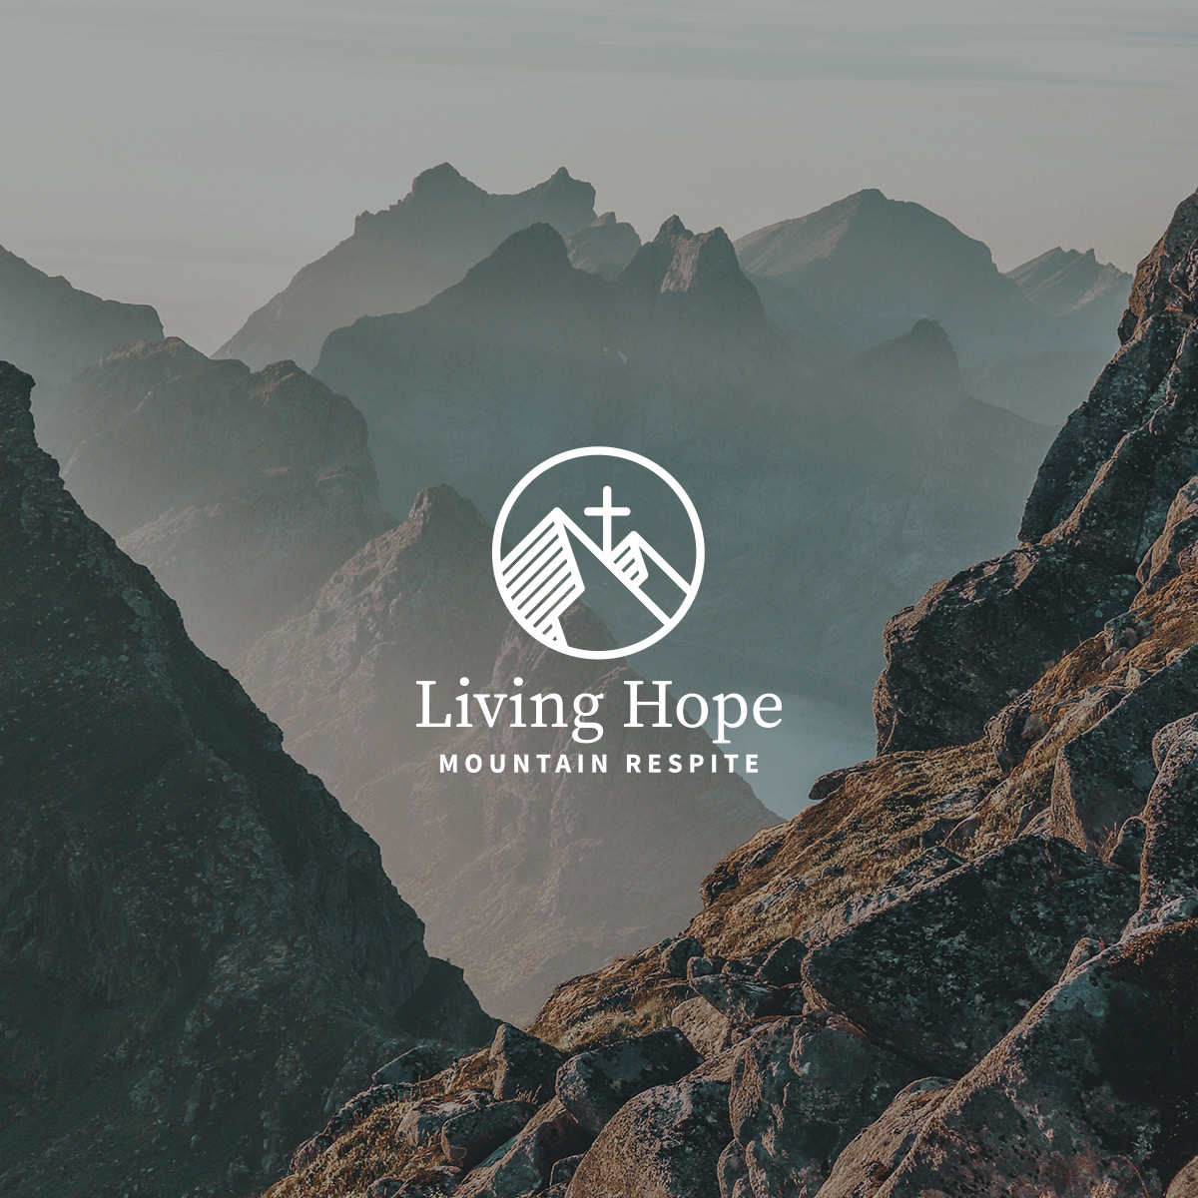 |  | Spring 2023 ministry update  The photo below is the YMCA of the Rockies Outdoor Chapel in Estes Park, CO. This majestic setting is where we culminate our respite weekend with our guests. We gather with a sweet depth of intimacy that developed throughout the weekend. The Lord’s presence, and His entrance into our pain forged this sweet intimacy. Hope was Authored by our Living Hope, Jesus, and facilitated by the Holy Spirit.  At the close of the retreat, we send out our guests by praying Numbers 6:24-26 over our them. “The Lord bless you and keep you; the Lord make his face to shine upon you and be gracious to you; the Lord lift up his countenance upon you and give you peace.”  We can depart in confidence knowing that even though the retreat ends, our Living Hope goes with us and promises to never leave us.  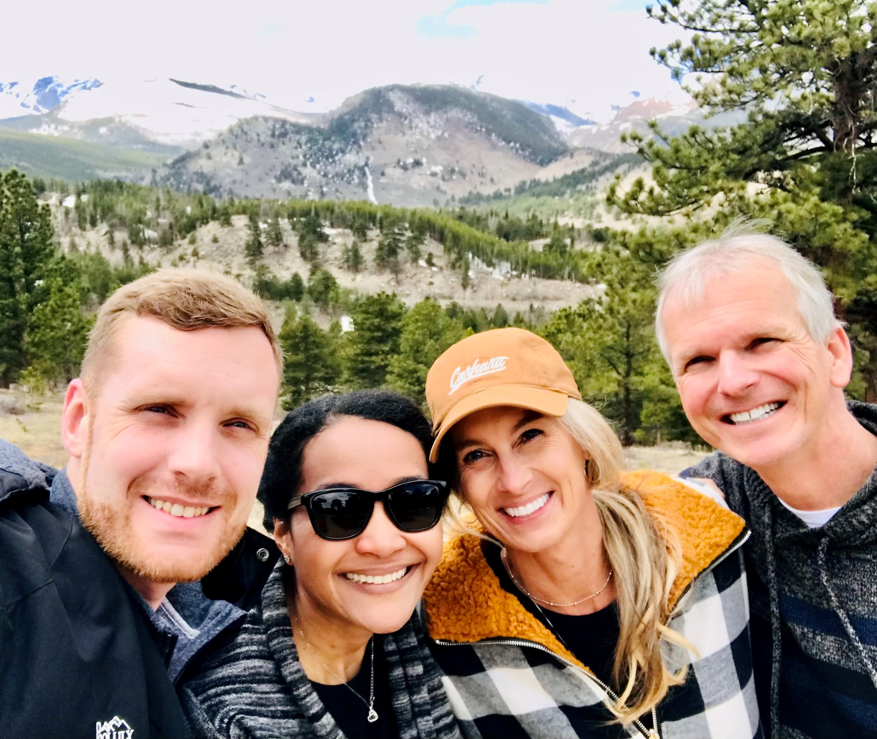  APRIL 2023 RESPITE RETREAT HIGHLIGHTS  The powerful prayers of many were evident. We prayed specifically for the weather which was originally forecasted to be cloudy. It actually snowed the day prior! On Friday morning, and throughout the weekend, the skies were Rocky Mountain blue (see below) providing a magnificent contrast with the snowcapped peaks. The time shared at the retreat was beautifully hard. It was intense yet the Holy Spirit was ever present guiding us, and a forever heart connection was created. The time shared included both laughter and crying, yet sure Hope.  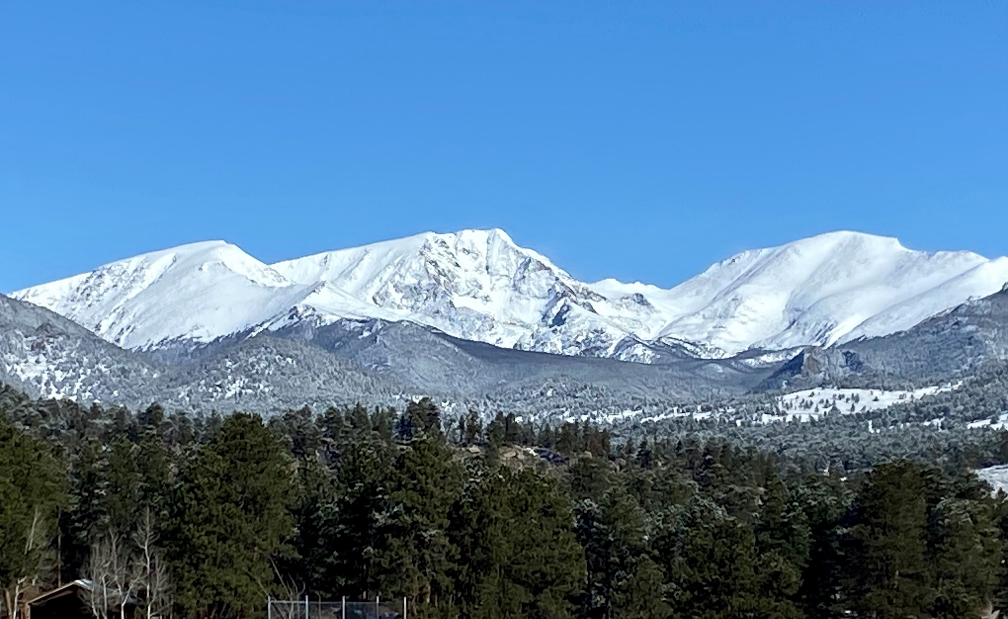  NEXT RETREAT DATE  The next respite retreat weekend is September 8-10, 2023.  HOPE PILLOW  The heart connection we make during a respite weekend is profound. One of the ways we like to remain connected is by blessing retreat couples with a daily reminder of our Living Hope, Jesus.  REMEMBERING DEREK  Living Hope Mountain Respite was born out of child loss and the reality of how the death of a child impacts a marriage. Ongoing is our journey of loss, and comforting others with the comfort we ourselves receive from God remains the mission.  Yet, on this, the 10th anniversary of Derek’s transitioning into his promised inheritance, we remember Derek. We simply miss doing life with him. We have gotten out of bed 3,650 times and remembered. No new memories, simply remembrances. We remember his sensitive spirit, his playful grin, his love of family and his heart for Jesus. Derek… we so very much love to hear his name and even typing it brings tears that make it hard to see. So, we give thanks to our Lord and Savior that upon Derek’s leaving us we did not have to surrender him to a dark void. Rather, we entrusted him into the arms of Jesus. Those same arms continue to open wide to comfort us as we remember.  Derek Matthew Packard (June 15, 1994-June 4, 2013)  PRAYER REQUESTS  - Next retreat: September 8-10, 2023. May God draw those couples that will be deeply encouraged by attending.  - Creating awareness of our unique ministry to grieving marriages remains our largest challenge. All the couples that have attended have learned of LHMR by word-of-mouth.  - Our marriage. We need intercession from the powerful prayers of many as we serve.

